Recurrent Neural Networks for Stock Market Prediction

Yi Zheng
Computer science
University of Texas at Dallas
Richardson,US
yxz180009@utdallas.edu
Qiang Yao
Computer science
University of Texas at Dallas
Richardson,US
qxy180009@utdallas.edu
Feifei Guo
Computer science
University of Texas at Dallas
Richardson,US
fxg180009@utdallas.edu
Xinyue Yu
Computer science
University of Texas at Dallas
Richardson,US
xxy170004@utdallas.edu

Abstract—Stock, as one of the most common types of investment nowadays, draws the attraction of many researchers due to its high risk. Analyzing and predicting the future trends of certain stock features given historical data become a hot topic in economic sphere. In our project, we decide to apply Long Short-Term Memory (LSTM) model, a popular RNN method for processing time sequential data, to predict the highest stock price in the future based on previous data sets including factors such as lowest price, highest price, opening price, closing price, trading volume, increase or decrease. LSTM has the advantages over traditional neural network model because its output for each time step is not only decided by the input at the current time instant, but also the states of previous time steps, which means LSTM can memorize previous input information and system state information, and figure out new outputs based on current network state[1].
Keywords— lstm, stock, predict, neural network

Introduction and Background work
Predicting the stock market is of great value nowadays because stock is an important way of investment. It is valuable if we can make an accurate prediction in stock market using machine learning. We try to build a model based on RNN (recurrent neural network) to do some prediction of stock market. There are several ways to predict a stock market from our background study. One way is to use a technique called Averaging mechanisms[2]. We predict the stock price of Day t+1 by calculating average price from a time window t to t-N. It is sensible because the stock cannot change a lot from day t to day t+1. On the other hand, RNN has a great value of predict the time-series model like stock market, especially LSTM, which allow us to fit the long-term and short-term data.

Technique and algorithm

Data Representation
If we set our time_step = 3 and input_size=1(Input features is “close price” only)

Input1=[[p₀],[p₁],[ p₂]] Label1=[[ p₃]]
Input2=[[ p₁],[ p₂],[ p₃]] Label2=[[ p₄]]
Input3=[[ p₂],[ p₃],[ p₄]] Label2=[[ p₅]]
……
Input_{n}=[[ p_{n-1}],[ p_{n}],[ p_{n+1}]] Label_{t}=[[ p_{n+2}])]]

We just predict one step forward at each input and we gather all of our output label and we are able to predict the change of the stock market.

Normalization
Since our data goes from 1100 to 3100 which has a large range of number. If we use the original dataset, we will come to out of scale issue and make pool prediction for our test data. Then we use the normalization technique. We use z-score normalization. We subtract mean of the price from the price and then divided by the standard deviation.
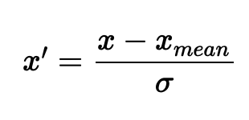
Equation. 1. Equation of Normalization.

LSTM Structure
RNN (Recurrent neural network), derived from neural networks, is one of the most useful deep learning technologies to process sequence data. RNNs can use their internal state (memory) to process sequences of inputs. This makes them applicable to tasks such as unsegmented, connected handwriting recognition [3] or speech recognition.[4][5].
In standard RNNs, it has the form of a chain of repeating modules of simple neural network structure, such as a single tanh layer. (shown in Fig. 1)
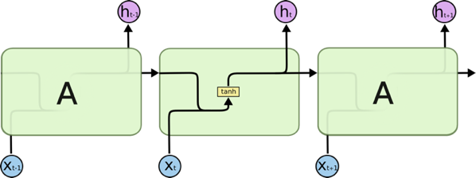
Fig 1. The repeating module in a standard RNN contains a single layer [4].
RNN model is born with the capability to process long sequential data and to tackle tasks with context spreading in time. The model processes one element in the sequence at one time step. After computation, the newly updated unit state is passed down to the next time step to facilitate the computation of the next element. Imagine the case when an RNN model reads all the Wikipedia articles, character by character, and then it can predict the following words given the context.
However, simple neural network that linearly combine the current input element and the last unit state may easily lose the long-term dependencies. To address the issue, researchers created a special neuron with a much more complicated internal structure for memorizing long-term context, named “Long-short term memory (LSTM)” cell.[7] It can learn for how much it should memorize from the old information, when to forget, when to make use of the new data, and how to combine the old memory with new input. Due to this property, LSTM can perform well to predict stock price.
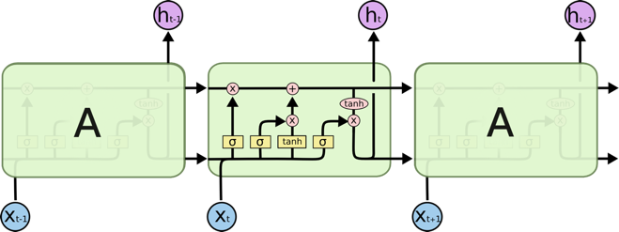
Fig 2. The repeating module in an LSTM contains four interacting layers[6].
LSTMs also have the similar RNN structure, but the repeating module is quite different. Instead of having a single neural network layer, there are four, interacting in a very special way. This special repeating module is called LSTM cell (the middle unit in Fig. 2).
To learn long-term dependencies, we need the information not only at the current time instant, but also from previous cells. LSTM model uses the term Ct to transport the dependency from the past. The forget gate layer, f_{t}, is used to forget certain amount of information from the previous cell state with the formula:
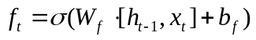 (1)
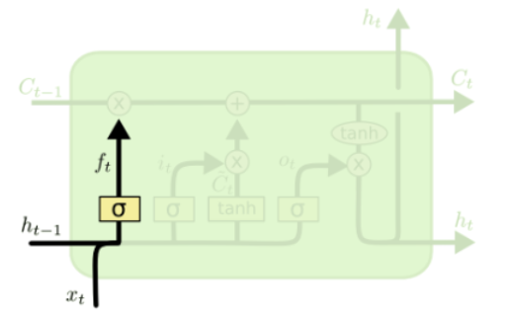
Fig.3. Forget gate, where ht-1 is the hidden state from previous layer and xt is the input at the current time instant [4].
Through the sigmoid activation function the output of the forget gate layer will be a real number between 0 and 1, where 0 means totally forget the previous dependencies and 1 means totally remember previous dependencies.
The input gate layer is used to decide how much information to include from the input t and the previous hidden layer ht-1. Similarly, a sigmoid function is used to produce a value between 0 and 1 to determine the proportion the remember from the input.
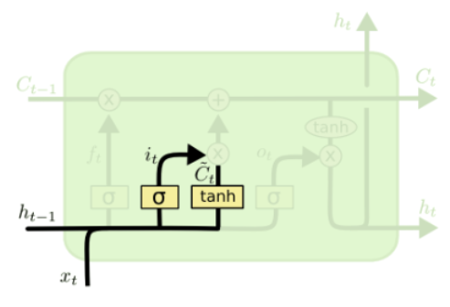
Fig.4. Input gate [4].
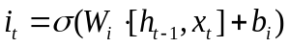 (2)
To update the overall cell state, we also need to calculate the cell state portion Ct from the current layer by applying a tanh function on the current input.
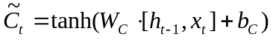 (3)
Finally, we can update the overall cell state C_{t} by multiplying the previous cell state C_{t-1} with the forget gate ratio ft and multiplying the current cell state with the input gate ratio and add them together.
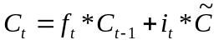 (4)
The output information is controlled by the output gate layer and hidden layer information ht is calculated by multiplying the output gate and the tanh result of the overall cell state.
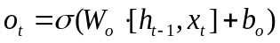 (5)
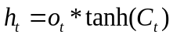 (6)
The above process is just the basic approach for the LSTM algorithm and people may use slightly different version of it. For the simplicity of our program, we will use the above algorithm to implement our functions.
In this project, we will use the LSTM networks for the prediction of stock price based on the prices of certain sequence of days in the past.
The loss function is the commonly used Minimum Square Error (MSE). The train data set and the test data are normalized using the same normalization process. We will explore the influence of the sequence length, learning rate and other parameters on the performance of our model.

Result and analysis

Analysis Rule
We use our model to predict the price of the stock in the next time sequence, we have no definition of train or test accuracy. we use the MSE for just test data to judge our model. And we show the graph for train loss and test dataset in every experiment.

Hyperparameters Tuning
Experiment Number | Parameters Chosen | Results
1 | Hidden_size=50  Epoch=50  Time_squence= 3  Learning_rate = 0.1 | Train/Test Split = 0.8/0.2  Size of dataset = 2517  Train MSE = 0.00064  Test MSE = 0.162
2 | Hidden size =100  Epoch = 50  Time_squence=3  Learning_rate = 0.1 | Train/Test Split = 0.8/0.2  Size of dataset = 2517  Train MSE =0.00067  Test MSE = 0.179
3 | Hidden size =50  Epoch = 50  Time_squence=10  Learning_rate = 0.1 | Train/Test Split = 0.8/0.2  Size of dataset = 2517  Train MSE =0.00060  Test MSE = 0.016
4 | Hidden_size=50  Epoch=100  Time_squence= 3  Learning_rate = 0.1 | Train/Test Split = 0.8/0.2  Size of dataset = 2517  Train MSE = 0.000632  Test MSE = 0.135
5 | Hidden_size=50  Epoch=50  Time_squence= 3  Learning_rate = 0.01 | Train/Test Split = 0.8/0.2  Size of dataset = 2517  Train MSE = 0.000722  Test MSE = 0.011

Visualization

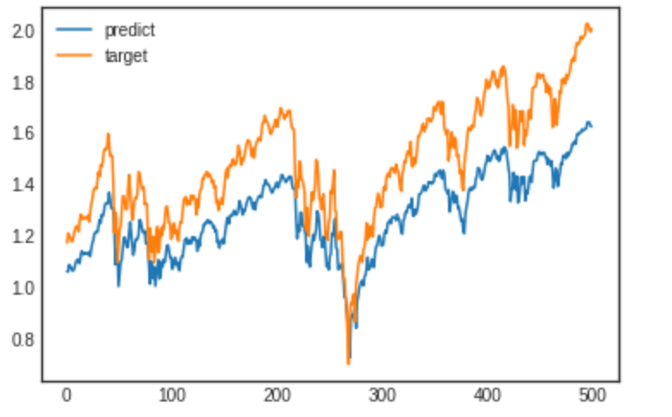
Fig.5. Comparison of Predict and Target in Experiment 1

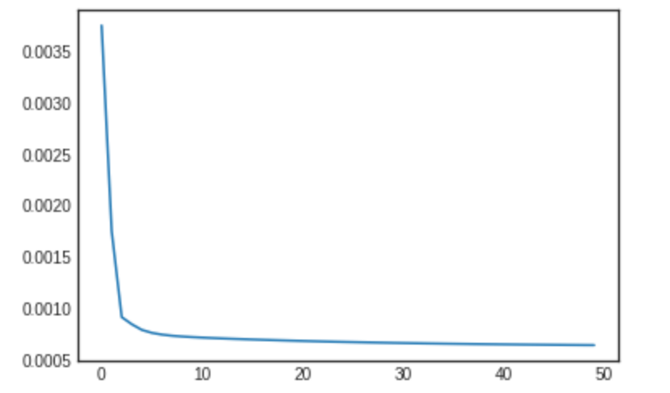
Fig.6. Training loss in Experiment 1
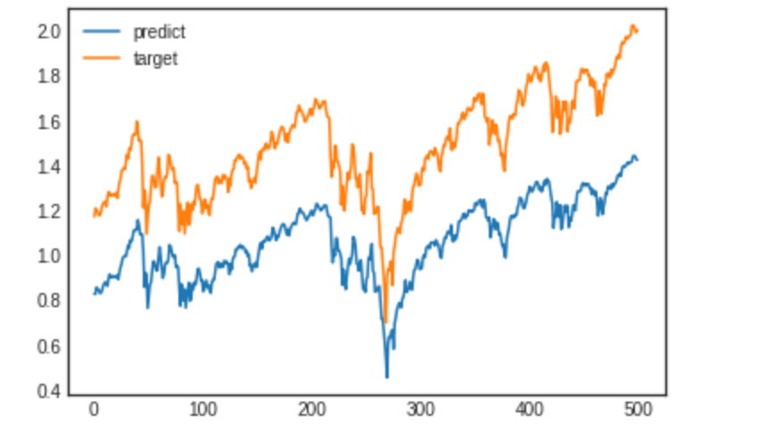
Fig.7. Comparisons of Predict and Target in Experiment 2
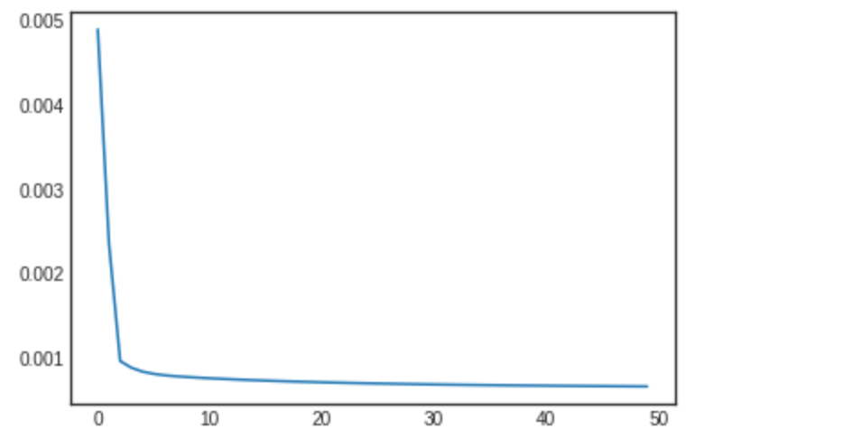
Fig.8. Training loss in Experiment 2

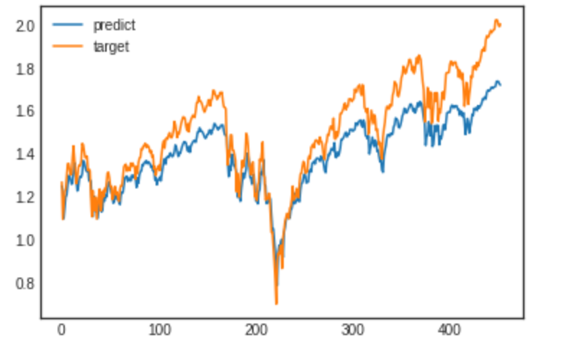
Fig.9. Comparisons of Predict and Target in Experiment 3

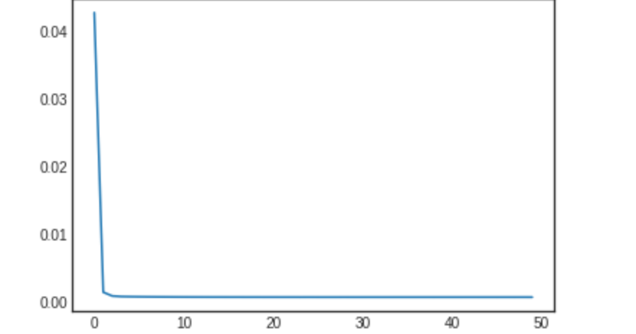
Fig.10. Training loss in Experiment 3
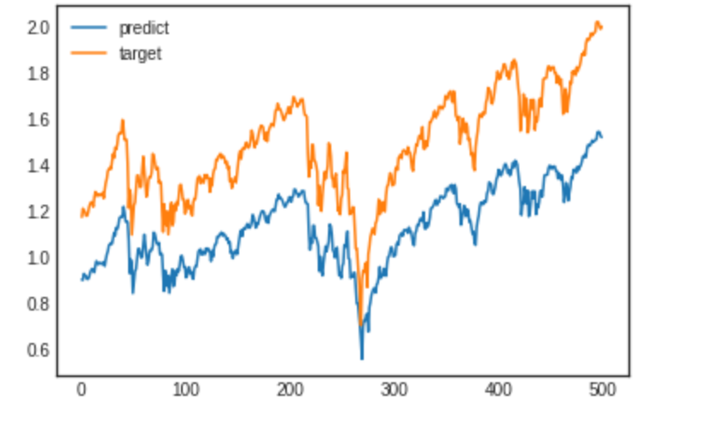
Fig.11. Comparisons of Predict and Target in Experiment 4
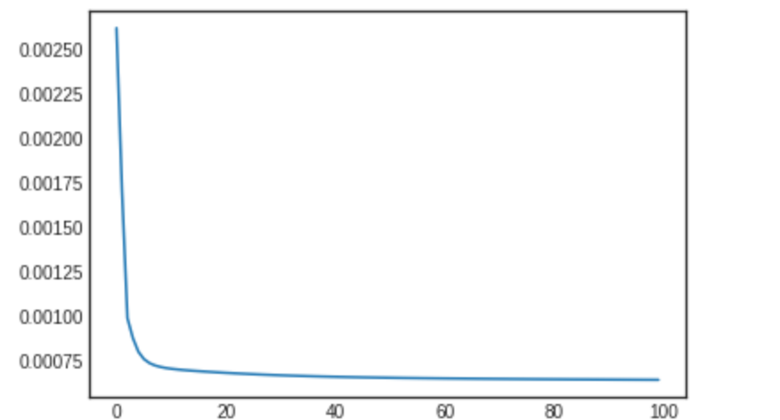
Fig.12. Training loss in Experiment 4

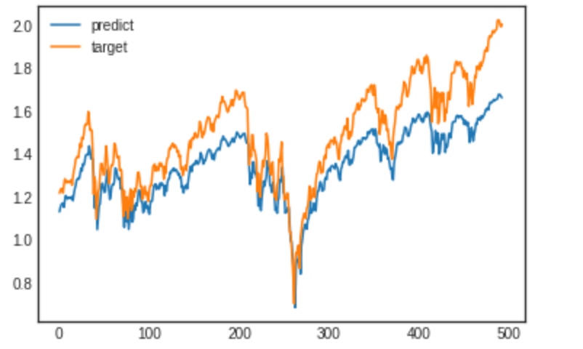
Fig.13. Comparisons of Predict and Target in Experiment 5
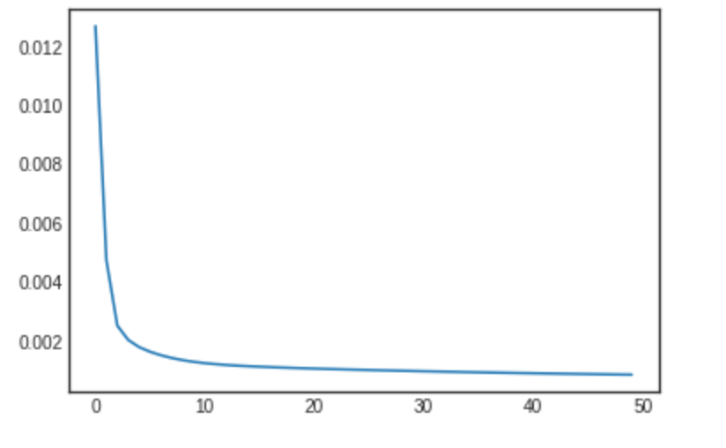
Fig.14. Training loss in Experiment 5

Effect of the hyperparameters
According to the figure above, we can see that the epoch and the hidden_size do not affect our train and test MSE too much. However, the increase of the time_sequence does reduce the MSE of the test dataset. It is reasonable because now we input more data (numbers of time_sequence ) to get the one more step data. And at the same time, the change of learning_rate will affect our model because an appropriate learning_rate can prevent the model from underfitting and overfitting.

Result
According to the graph shown above, we can see that the predictions and targets are similar to each other and they almost have the same trend. i.e. It is reasonable to use LSTM model to do time series prediction in stock market.

Conclusion and future work
By using LSTM model, it is able to memorize the historical data and make some prediction for the future stock price. It provides a good reference for analysts and investor or any people interested in stock market. However, it is not always stable because the stock market is affected by a lot of information like the consensus and confidence from people.

The future work will focus on the following two aspects:
Figure out more features about the stock market which may helper to predict the stock market. And at the same time, it would be better if we can predict some more steps forward.
Use the regularization (or dropout) to the neural network.

References
- CSLT Group. [n. d.]. Historical Volatility Prediction based on LSTM. http://cslt.riit.tsinghua.edu.cn/mediawiki
- https://www.datacamp.com/community/tutorials/lstm-python-stock-market
- Graves, A.; Liwicki, M.; Fernandez, S.; Bertolami, R.; Bunke, H.; Schmidhuber, J. (2009). "A Novel Connectionist System for Improved Unconstrained Handwriting Recognition" (PDF). IEEE Transactions on Pattern Analysis and Machine Intelligence. 31 (5):Sak, Hasim; Senior, Andrew; Beaufays, Francoise (2014). "Long Short-Term Memory recurrent neural network architectures for large scale acoustic modeling" (PDF).
- Sak, Hasim; Senior, Andrew; Beaufays, Francoise (2014). "Long Short-Term Memory recurrent neural network architectures for large scale acoustic modeling" (PDF).
- Li, Xiangang; Wu, Xihong (2014-10-15). "Constructing Long Short-Term Memory based Deep Recurrent Neural Networks for Large Vocabulary Speech Recognition". arXiv:1410.4281 [cs.CL].
- http://colah.github.io/posts/2015-08-Understanding-LSTMs/
- Hochreiter, Sepp; Schmidhuber, Jürgen (1997-11-01). "Long Short-Term Memory". Neural Computation. 9 (8): 1735–1780. doi:10.1162/neco.1997.9.8.1735.

